**CMPE273: Enterprise Distributed Systems Lab 2 Kafka And MongoDB**

**Goals**

The goal of this system to provide ease in sharing file and collaboration for user by providing functionalities like uploading, listing, creating, sharing or starring a file or directory using Kafka and MongoDB.

**Purpose**

The purpose of this system is that the user can upload files, create a new directory, delete a directory, list all files and folders, download, share, star by signing up with application. User should also be able to maintain his profile and server should be able to log user’s activity.

**System Design**

Technologies Used For Dropbox

FrontEnd Framework : ReactJS, HTML5, BootStrap

BackEnd Framework : NodeJS, Kafka

Database : MongoDB

Testing Framework : JMeter, Mocha

Tools IDE : WebStorm

**System Design for Dropbox Application:**

1. On accessing the Dropbox URL, the user is redirected to the Welcome page which contains a button.

2. On click of the button, the user is redirected to the Login Page first.

3. If the user is logging in for the first time, the user can sign up by going to Sign up page.

4. Credentials like email, first name, last name, and password are taken. To ensure user enters the proper data, React Validations are put to ensure consistency.

5. To ensure confidentiality, the password is stored by encrypting it with bcrypt hashing algorithm.

6. After Signup, the user can Log in with the credentials. The password is decrypted and matched with the database to ensure authenticity. Passport JS is used for authentication and providing user with single sign-on facility.

7. On Signup, a folder with the user id of user is created so that the files can be uploaded in that folder.

8. After Log In, the user is redirected to the HomePage. The Homepage shows the list of all the previous files uploaded by the particular users.

9. The user can upload a new file by clicking “ChooseFile” button which provides the dialog box.

10. The user can download file by clicking on the download link of the file.

11. The user can make a new directory in its user space and also can delete the created directory.

12. The files can also be starred, un-starred based on the user preference.

13. The file can be shared to an individual email address and to the group of users created by the user who wants to share the file.

14. The user can get his activity log of when he/she created/deleted a file or folder.

15. User can update his profile and retrieve it whenever needed.

16. The user can logout once it has completed uploading file.

**Architecture Diagram:**

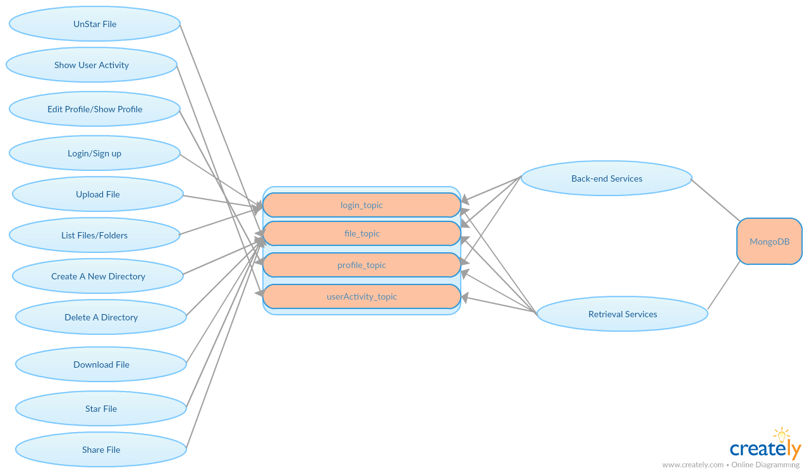

**Results**

**Sign Up page of Dropbox.**

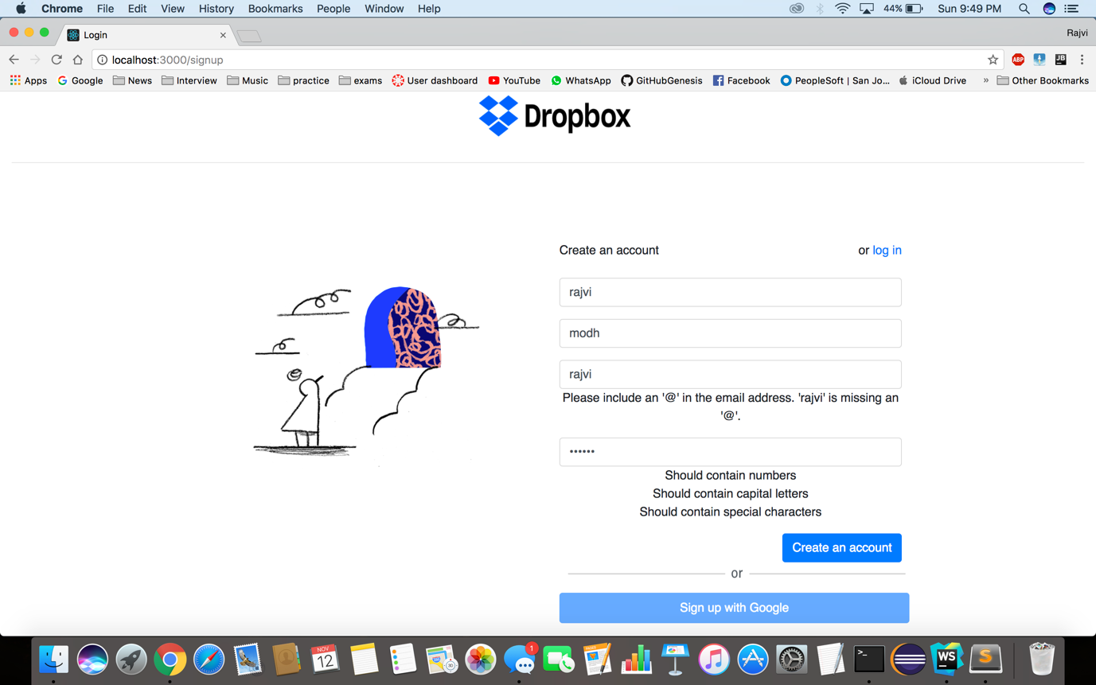

**Login Page of Dropbox.**

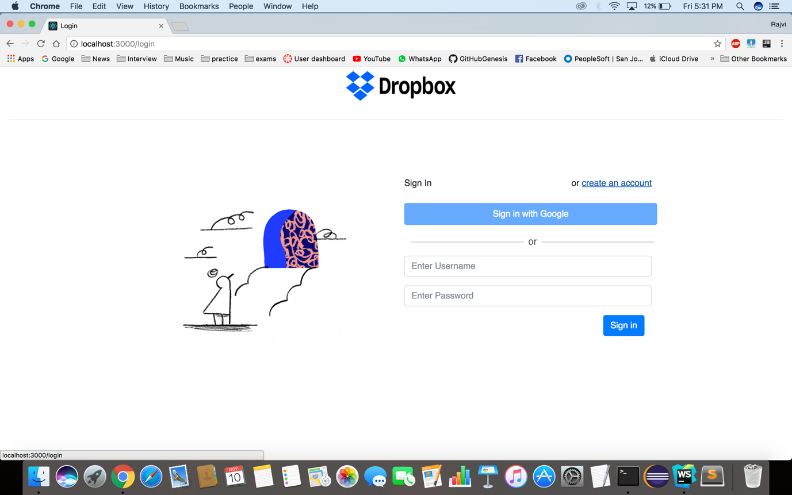

**Welcome Page after successful login.**

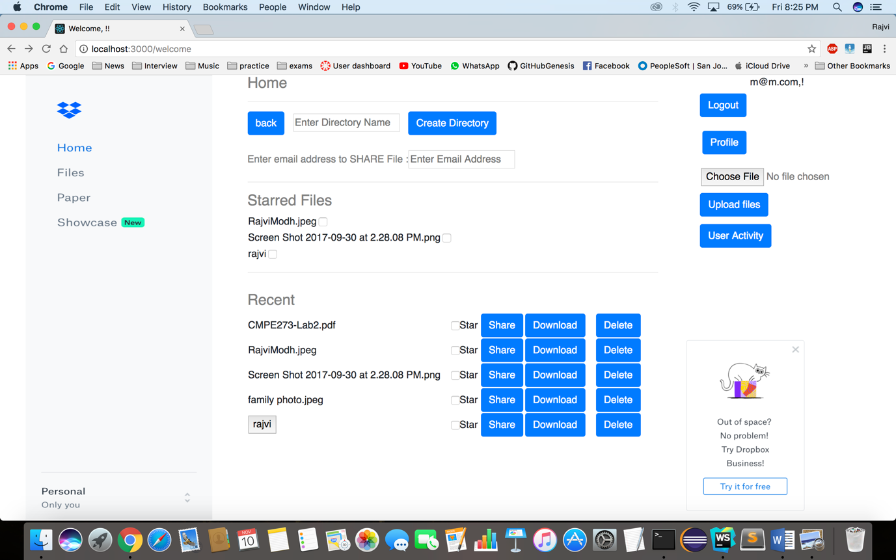

**Make files/directory : On clicking create directory, directory named “abc” is created.**

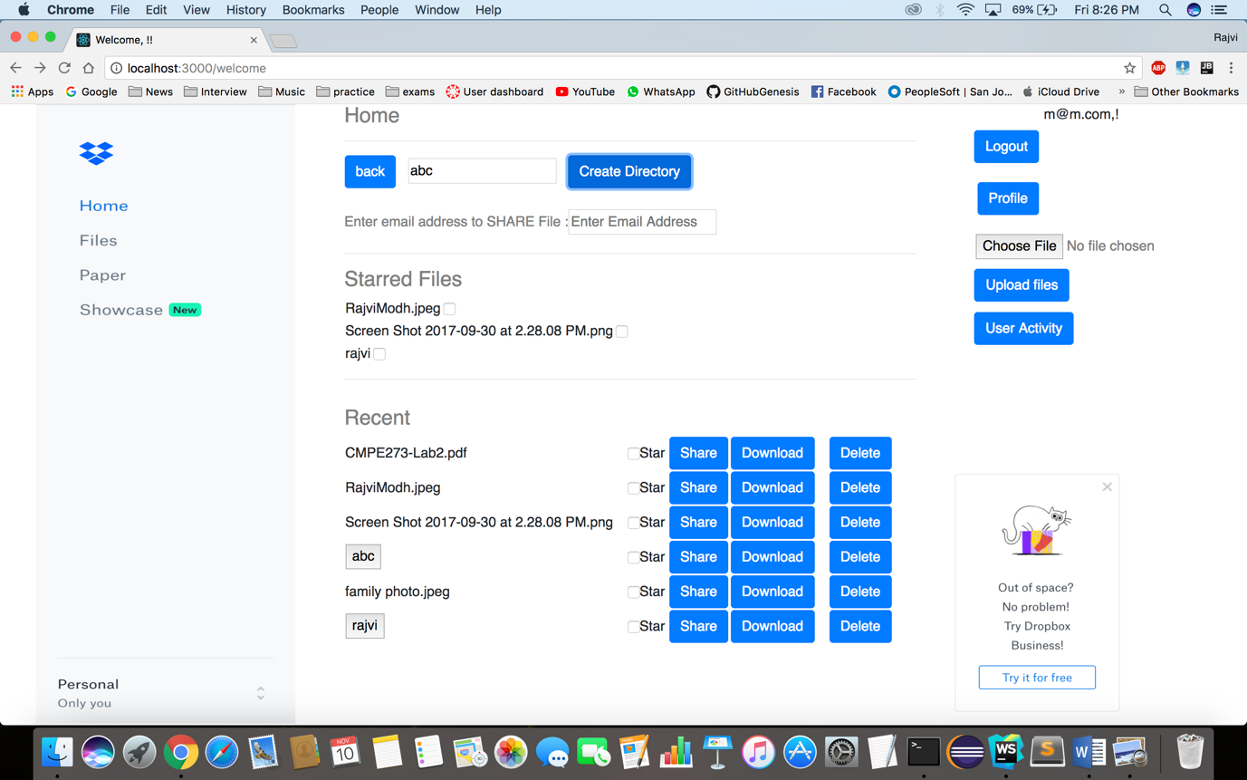

**Delete files/directory : On clicking delete button, directory/files gets deleted.**

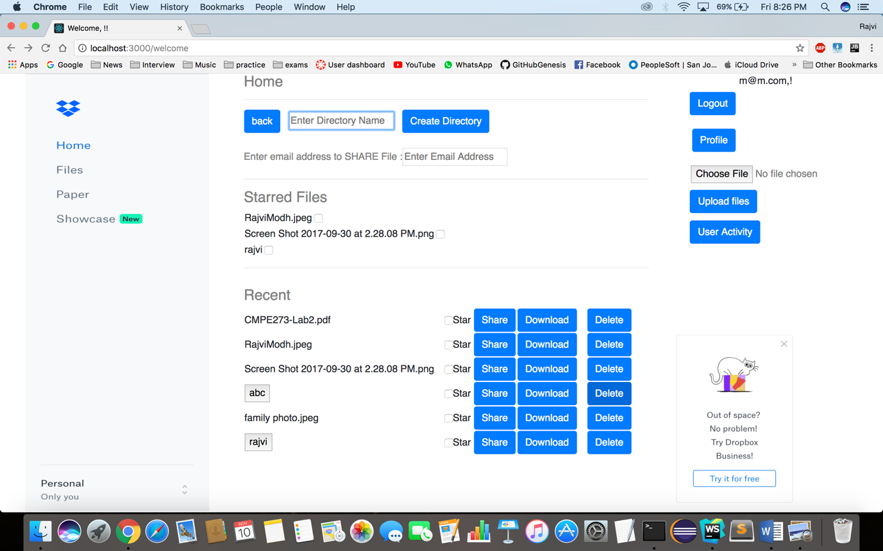

**Below shown that the directory “abc” is deleted from the list.**

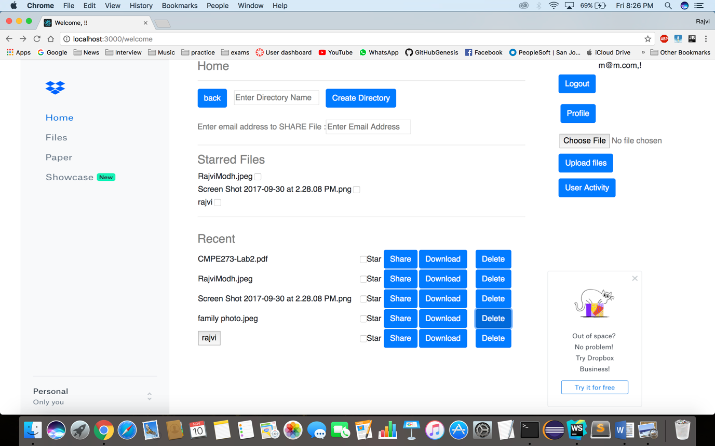

**Download file: User can download the file on clicking download button.**

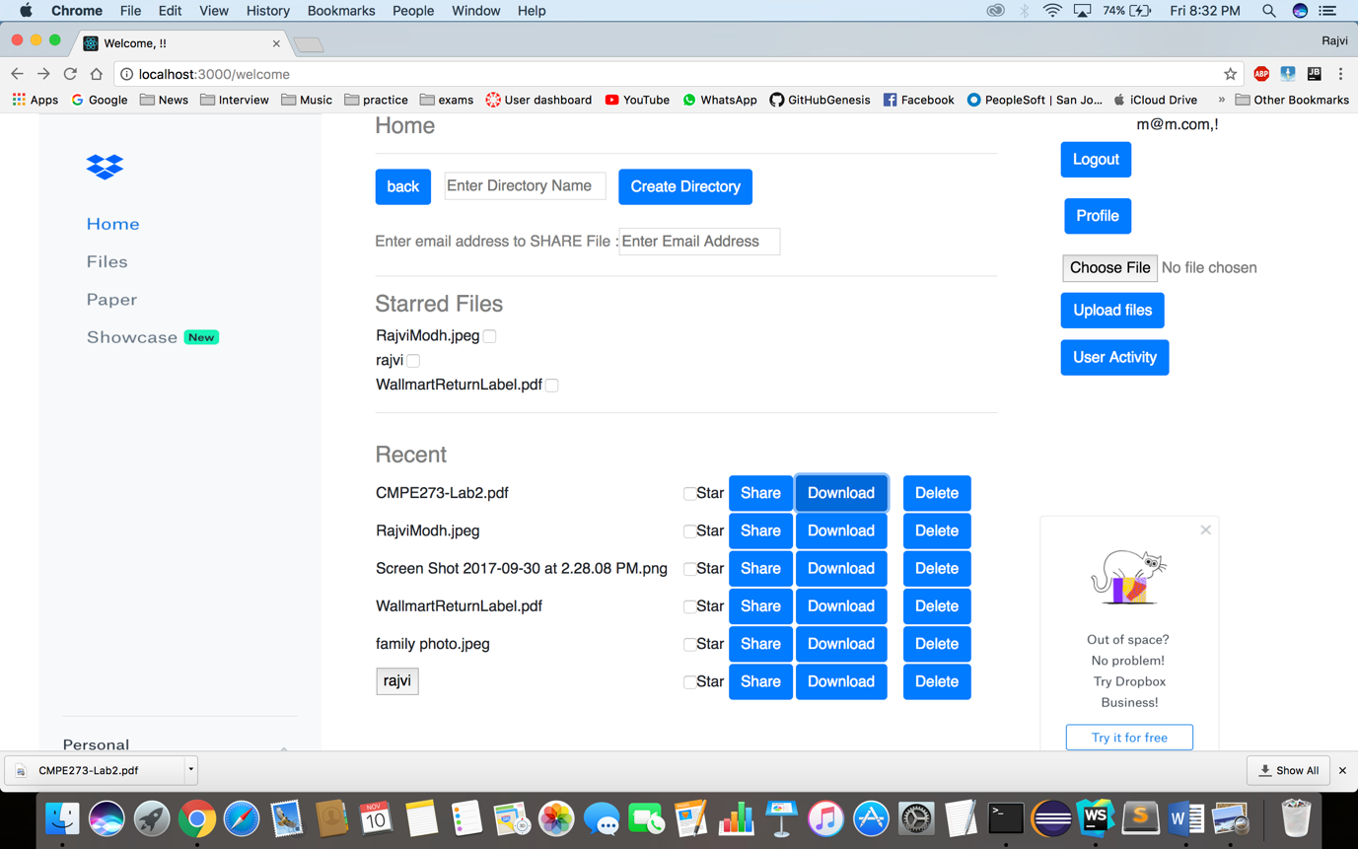

**Upload file: User can upload any type of file.**

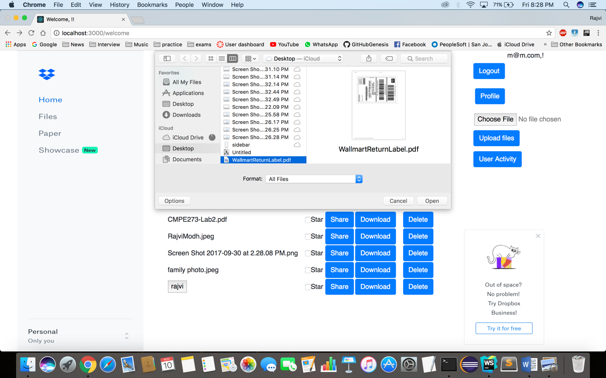

**Below shown that the chosen file named “WalmartReturnLabel.pdf” is uploaded and listed on homepage.**

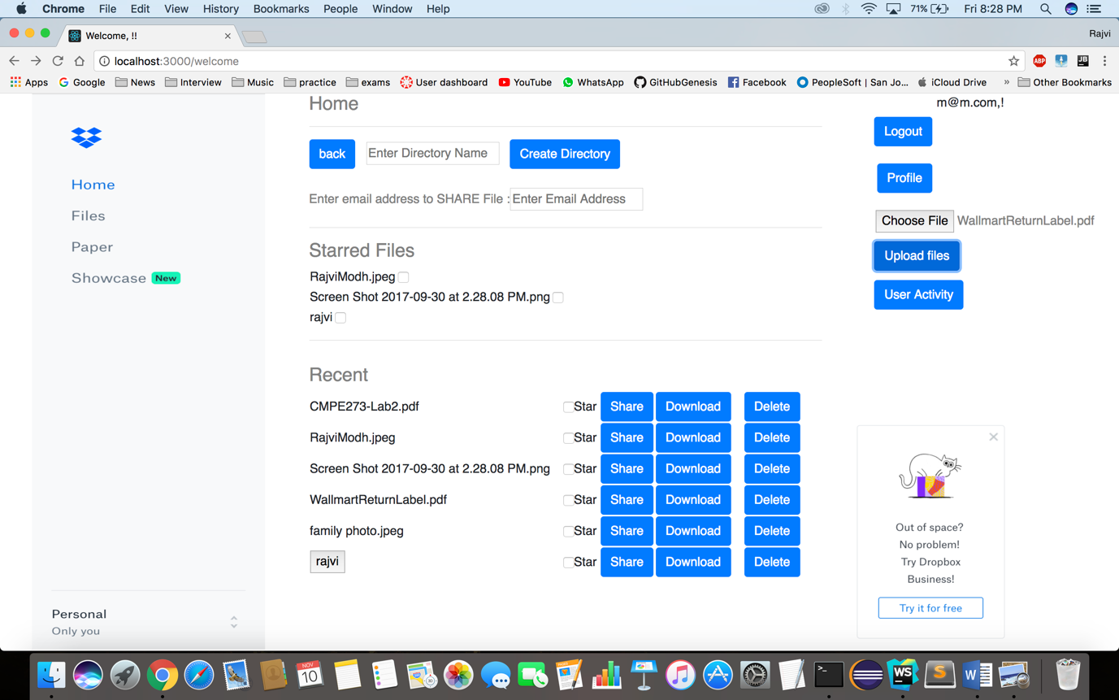

**Star A File/Directory: User can star a file/folder by clicking the “Star” checkbox.**

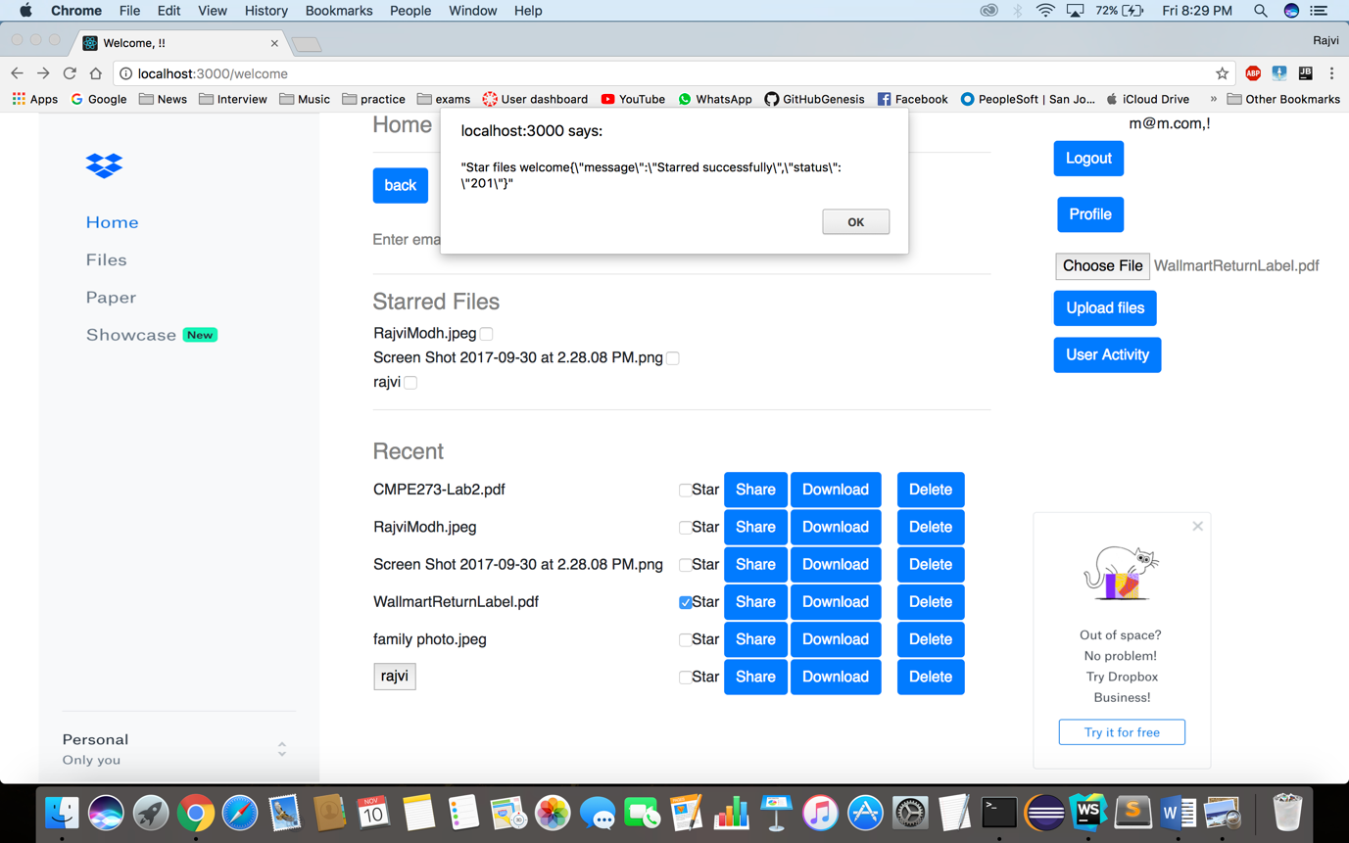

**Files starred by user is shown under different section named “Starred files”.**

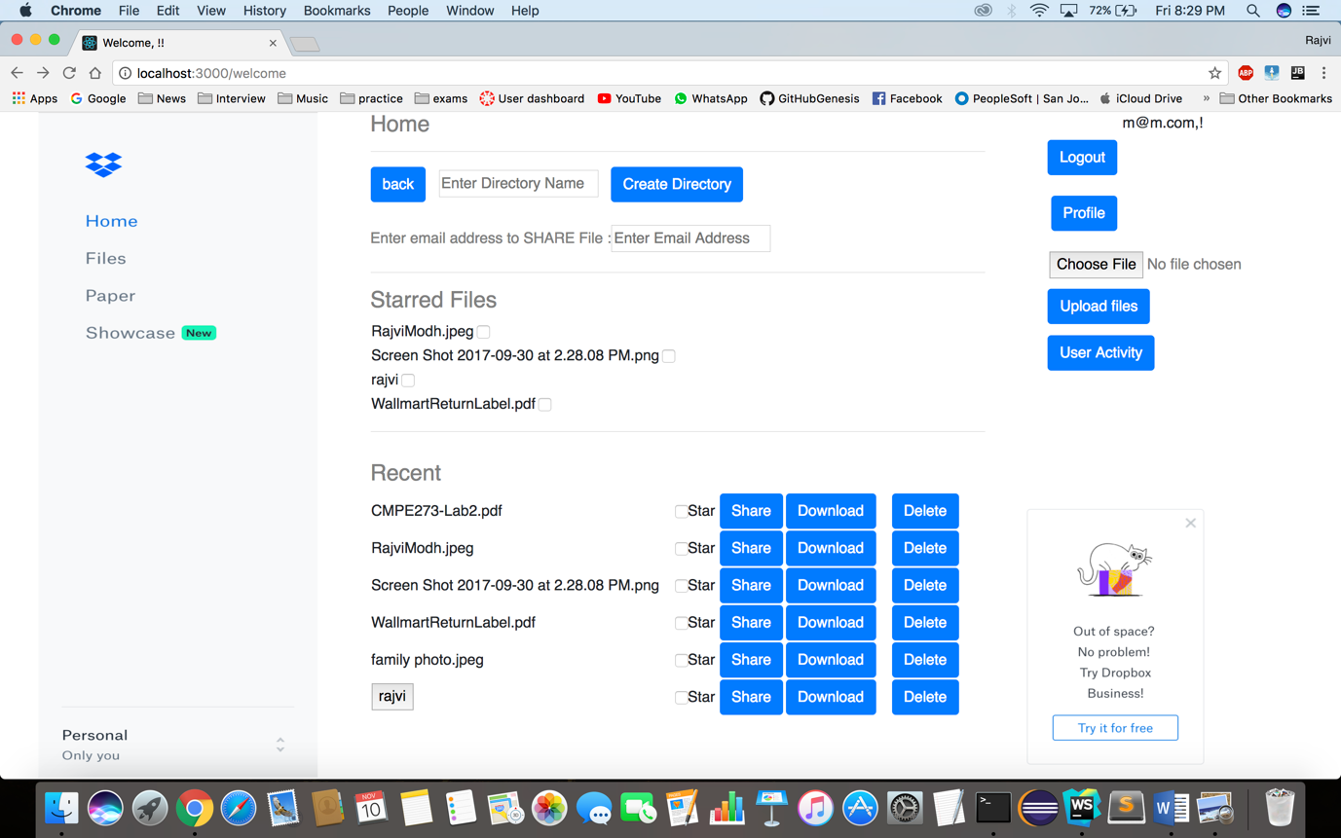

**UnStar a File/Folder: User can un star a file/folder by clicking on the checkbox under Starred Files section.**

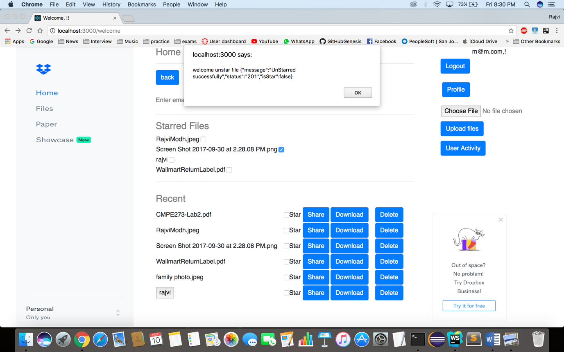

**Below shown that file is unstarred.**

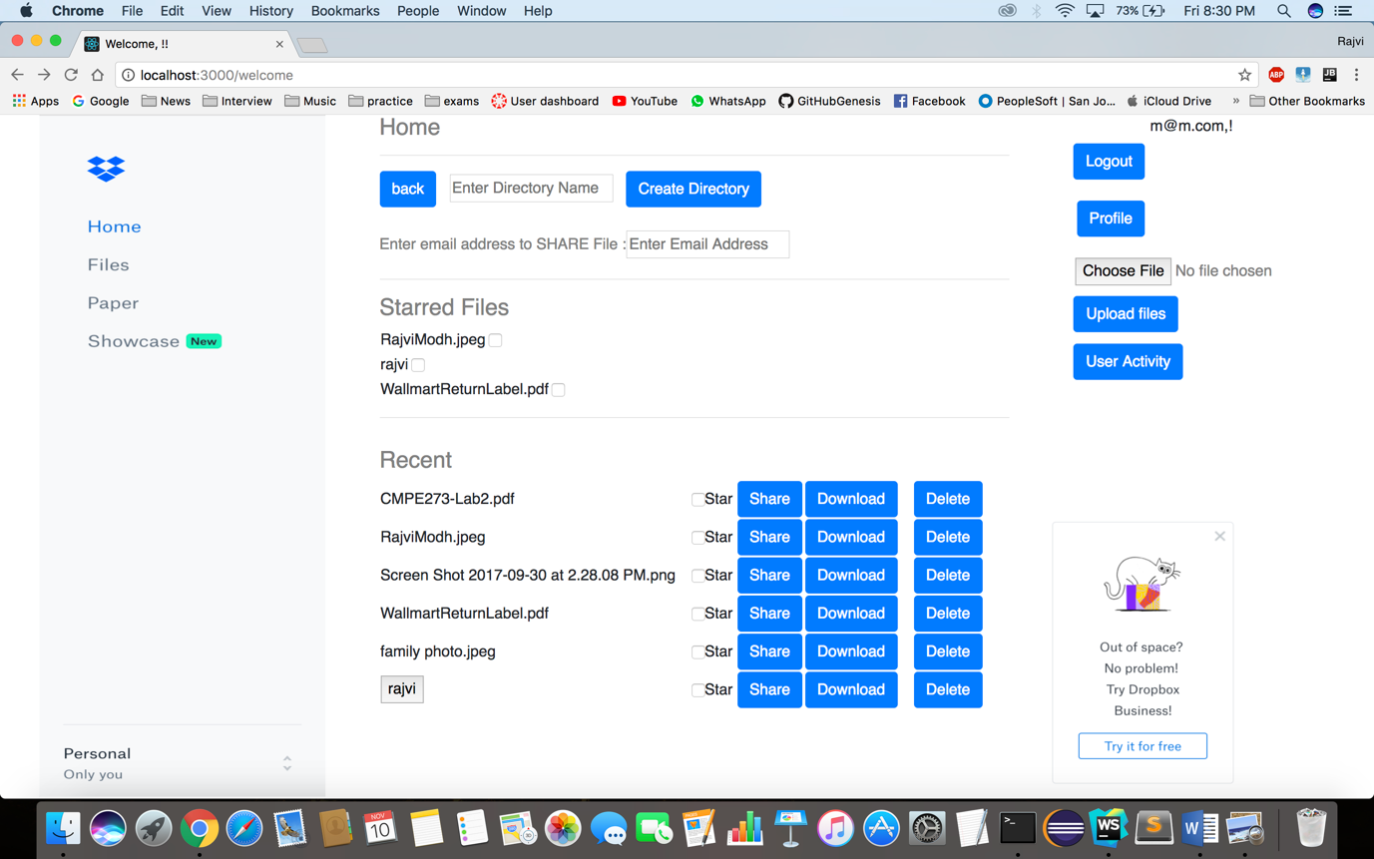

**Share a File: On writing the email address in the textbox provided, and then clicking share button, shares the file to the particular email.**

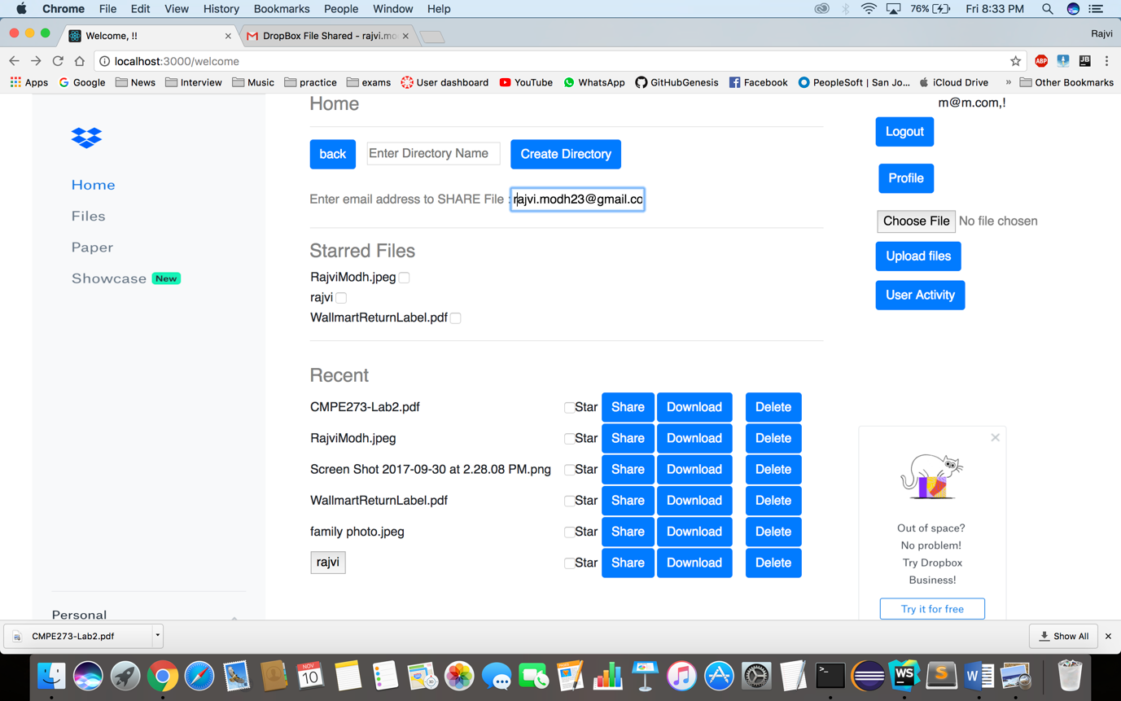

**Below shown the confirmation for Sharing.**

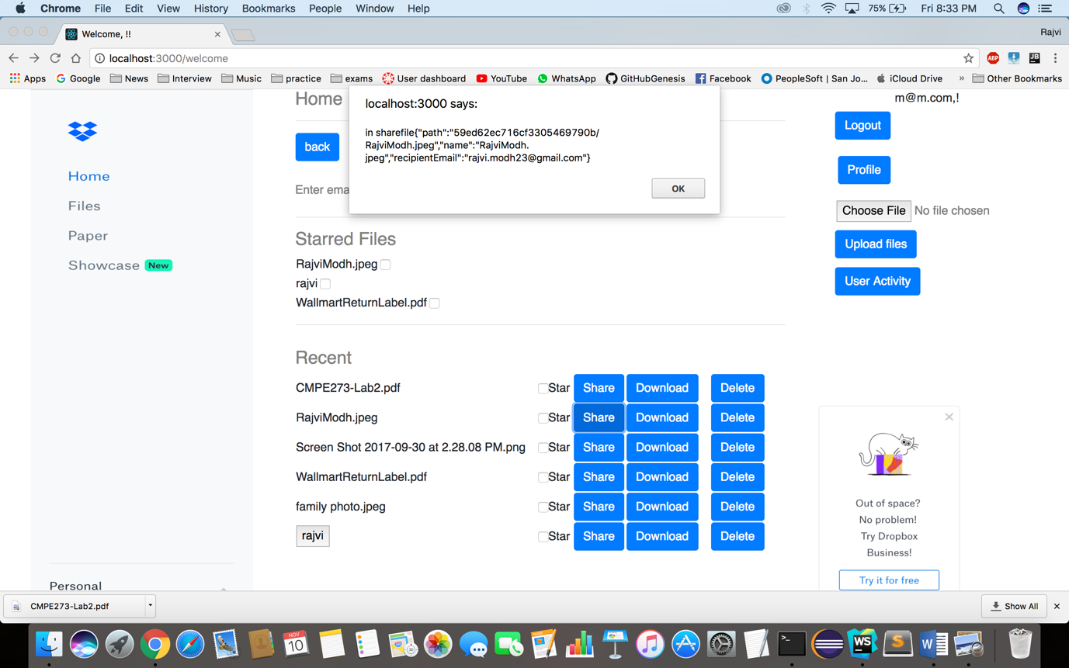

**Below shown that the file is shared and this file can be downloaded later.**

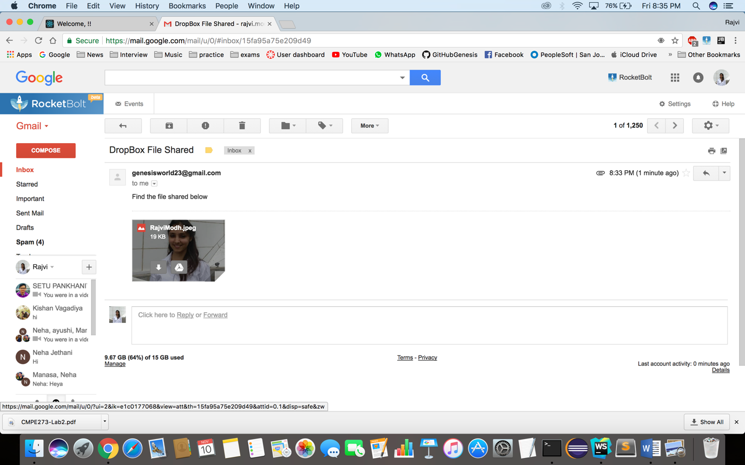

**User Profile/Interests: Profile of the user is displayed on landing this page.**

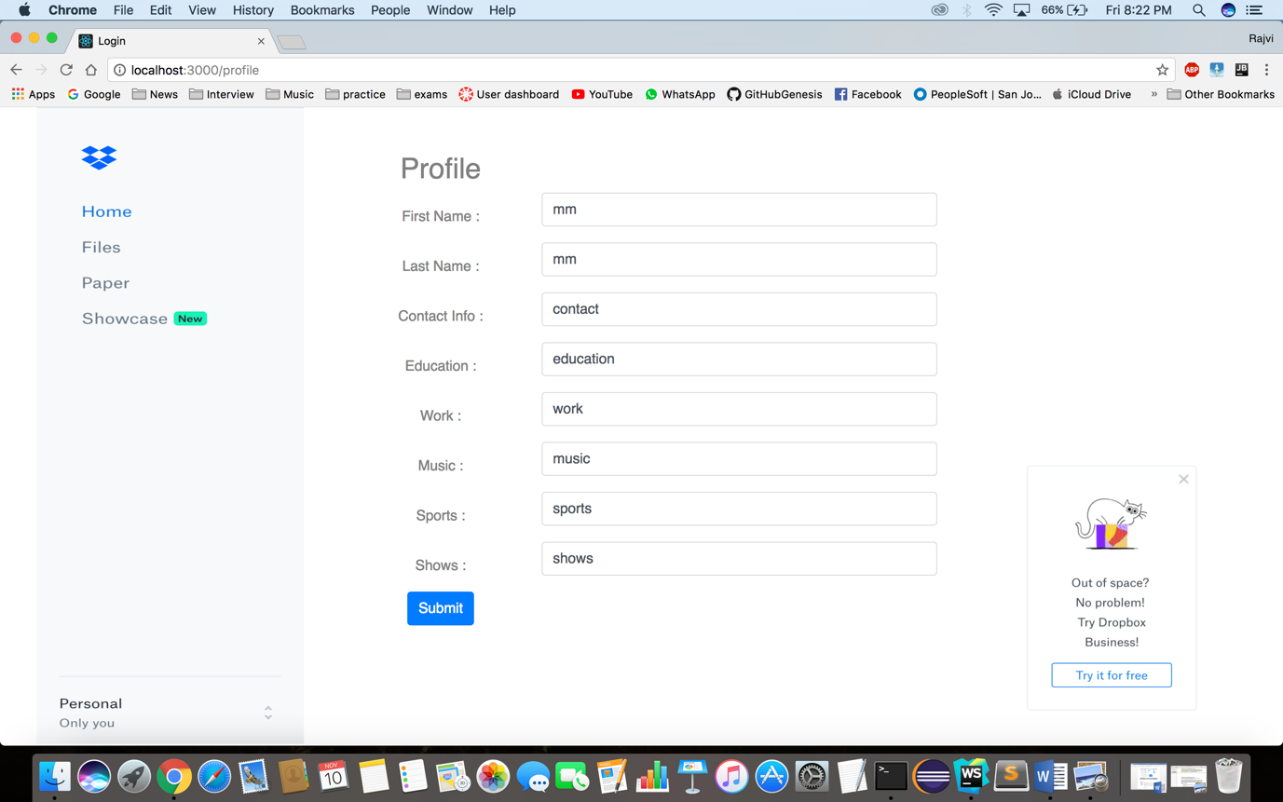

**Update User Profile/Interests: Profile can be updated by editing details and clicking on Submit button.**

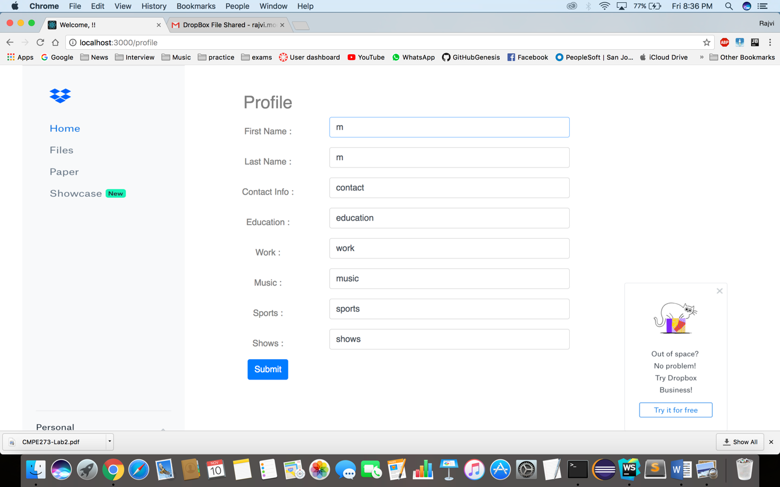

**User Activity: User Activity of the user is logged to show that at what timestamp the user performed which activity**

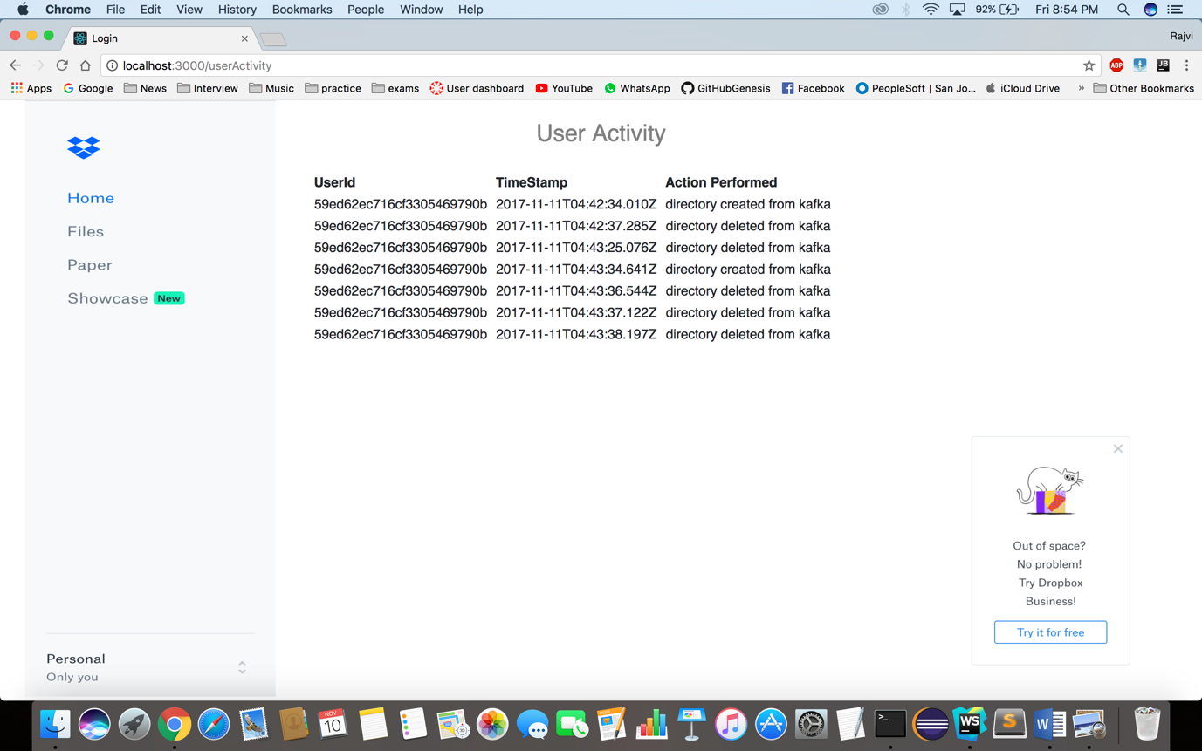

**Logout: On logout, session is destroyed.**

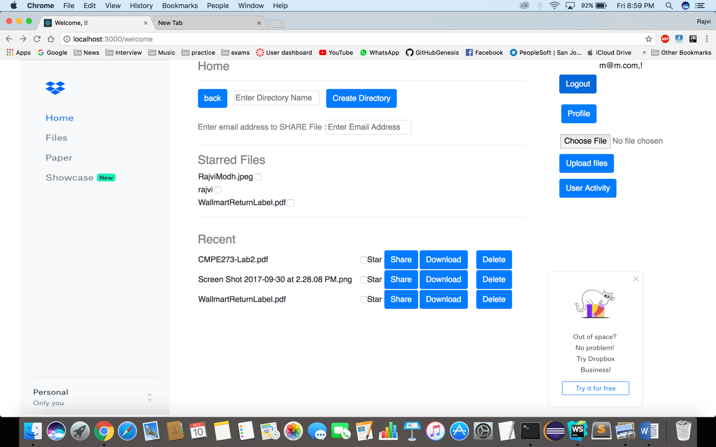

**Below shown is the screen after logout.**



**Performance**

1. **WITHOUT CONNECTION POOLING :**

**For 100 concurrent users without connection pooling:**

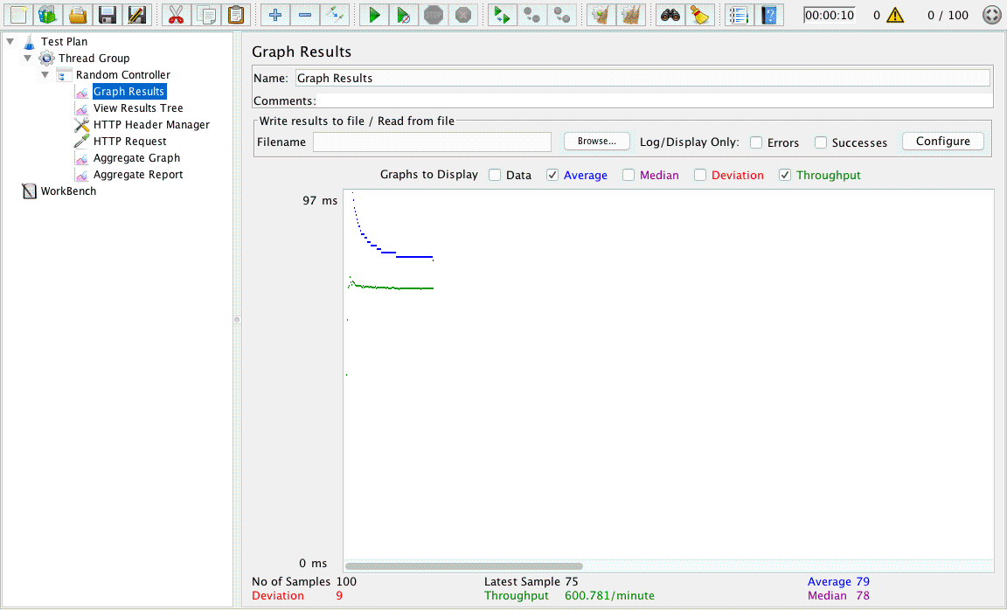



**For 200 concurrent users without connection pooling:**

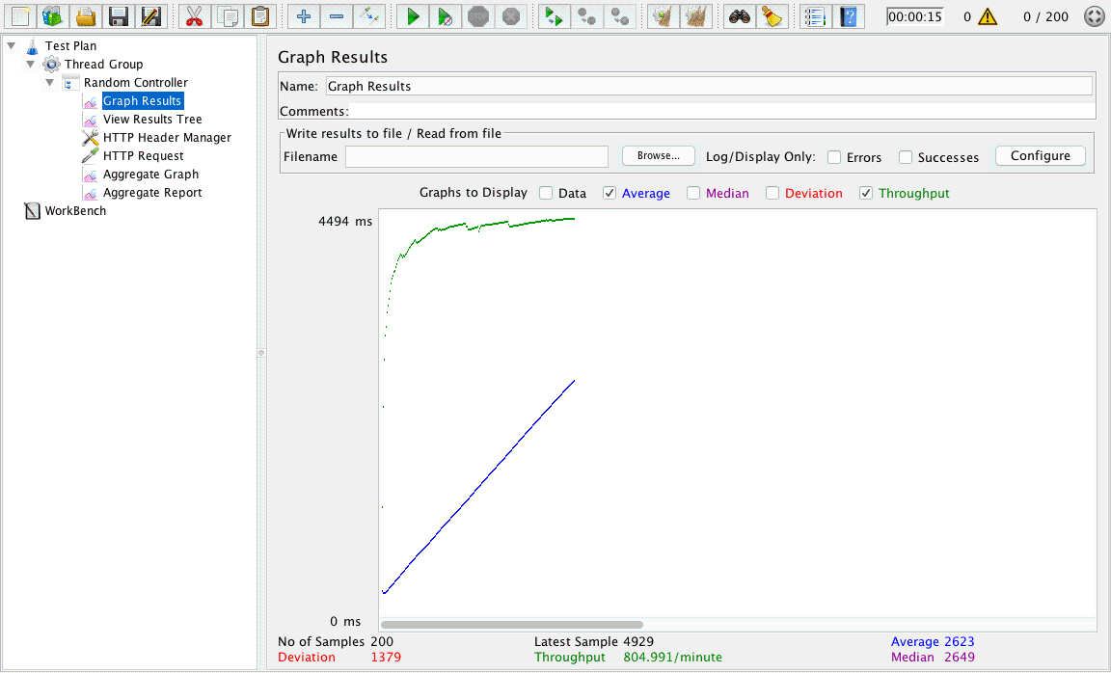



**For 300 concurrent users without connection pooling:**

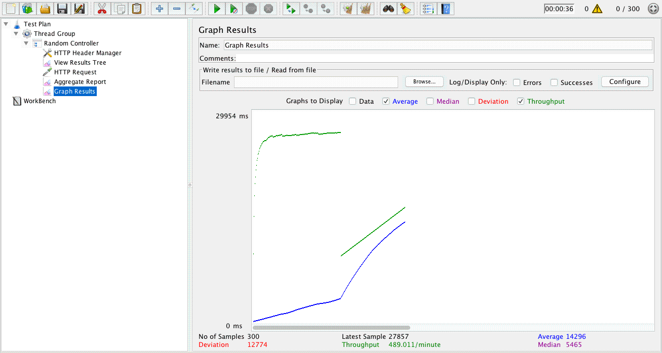

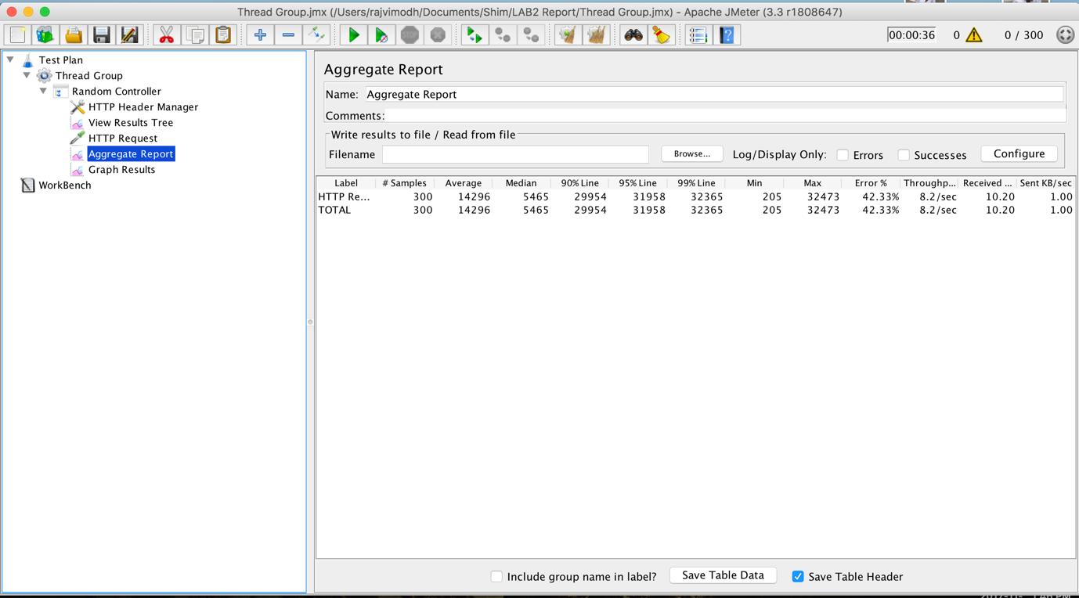

**For 400 concurrent users without connection pooling:**

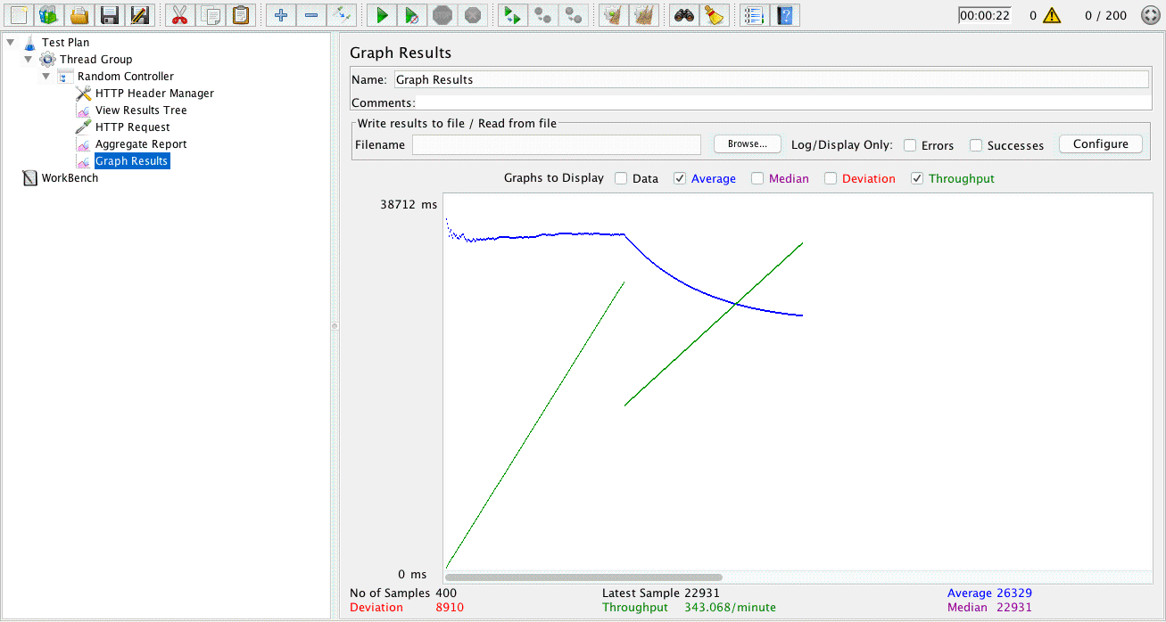

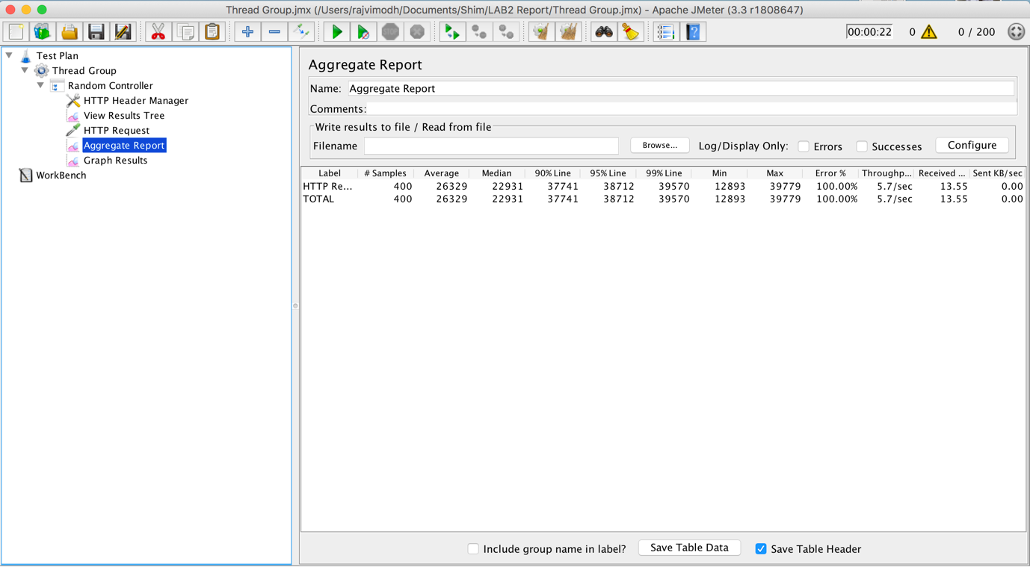

**For 500 concurrent users without connection pooling:**

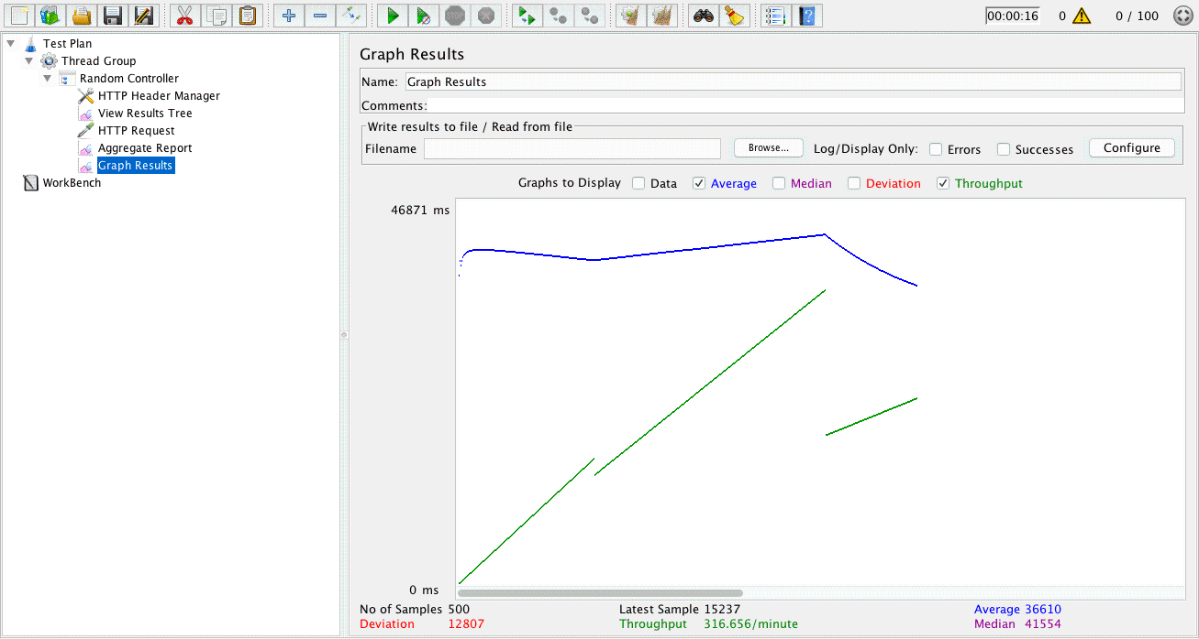

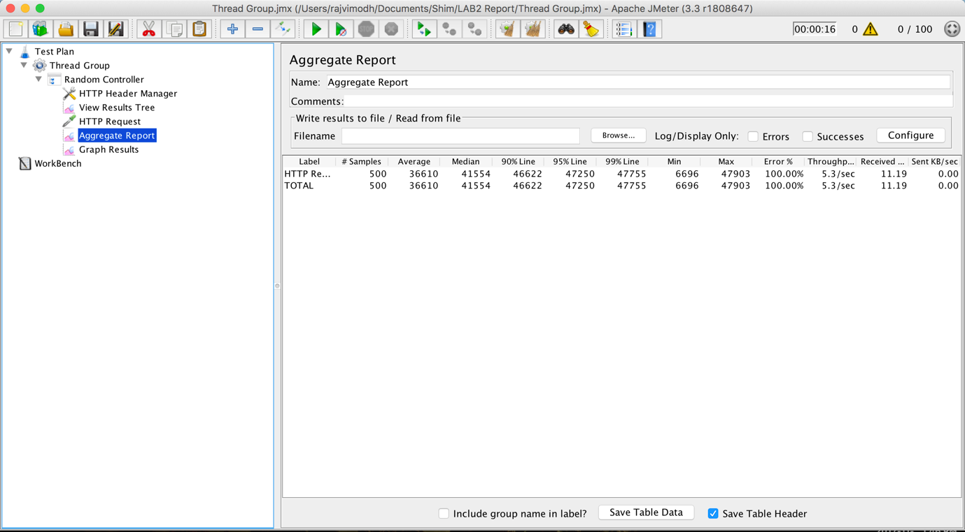

1. **WITH OWN IMPLEMENTATION OF CONNECTION POOLING**

**For 100 concurrent users with own implementation of connection pooling:**

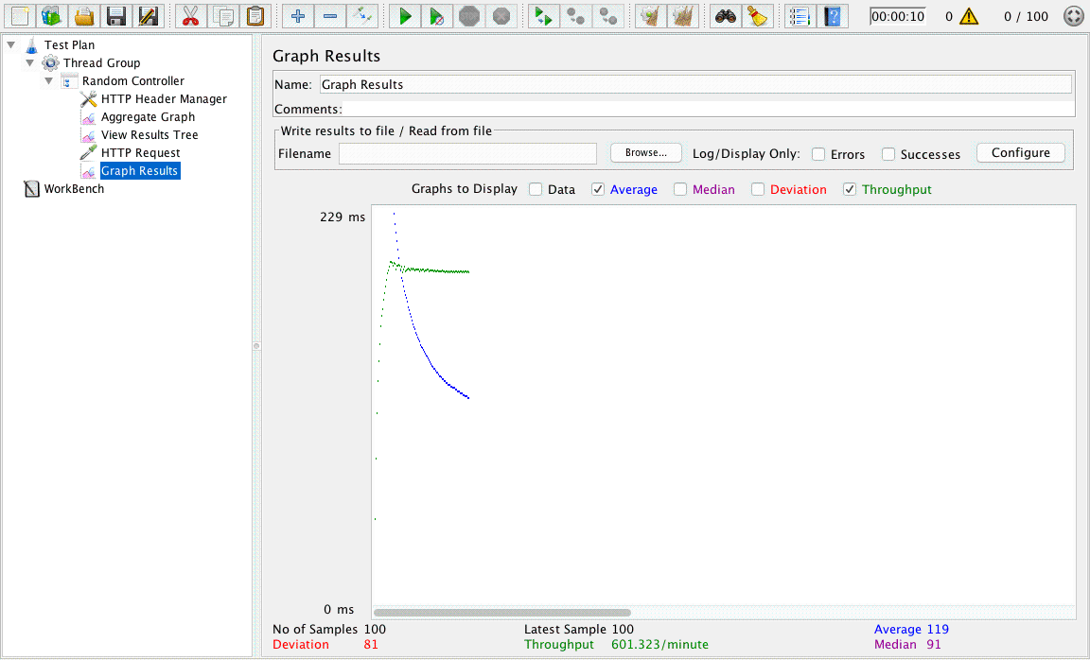

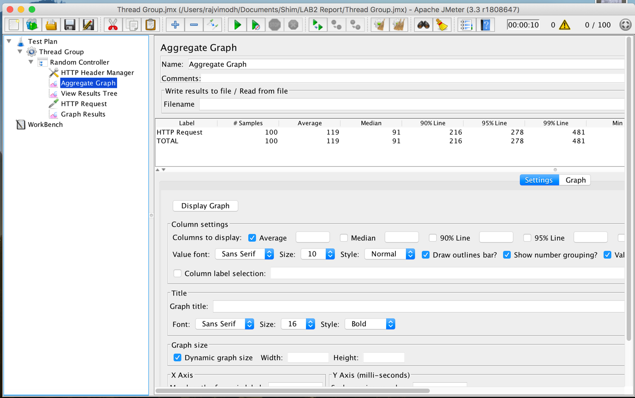

**For 200 concurrent users with own implementation of connection pooling:**

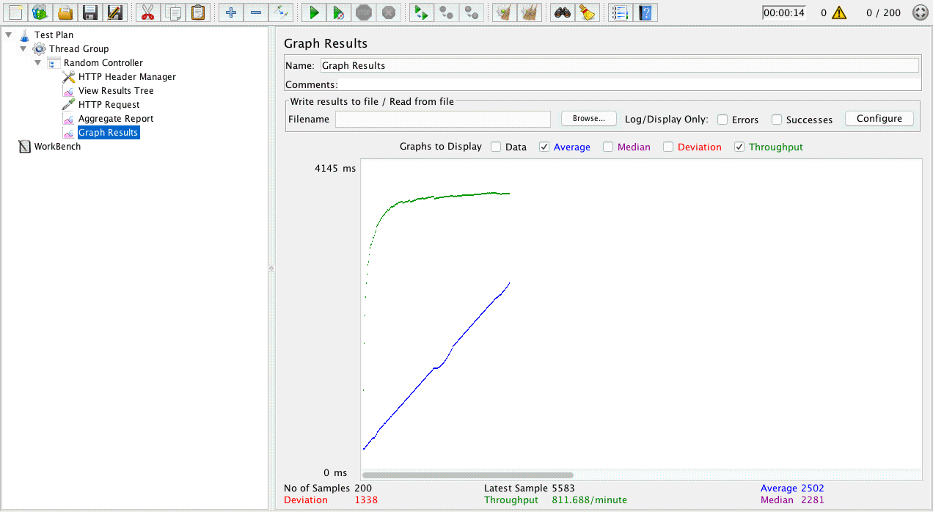

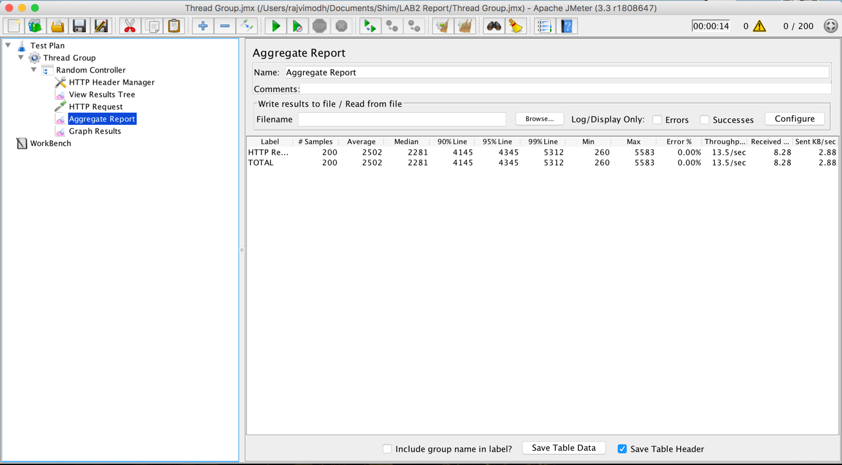

**For 300 concurrent users with own implementation of connection pooling:**

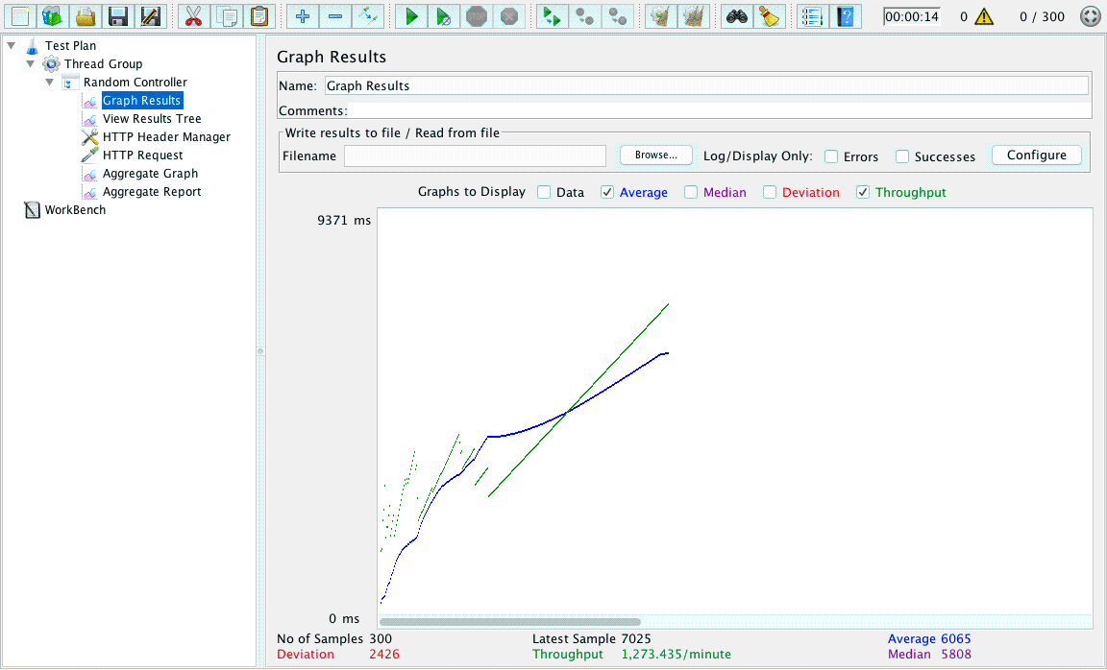



**For 400 concurrent users with own implementation of connection pooling:**

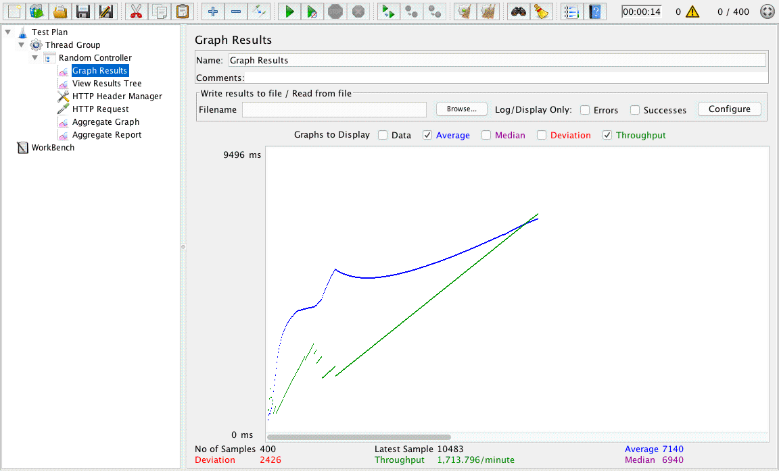



**For 500 concurrent users with own implementation of connection pooling:**

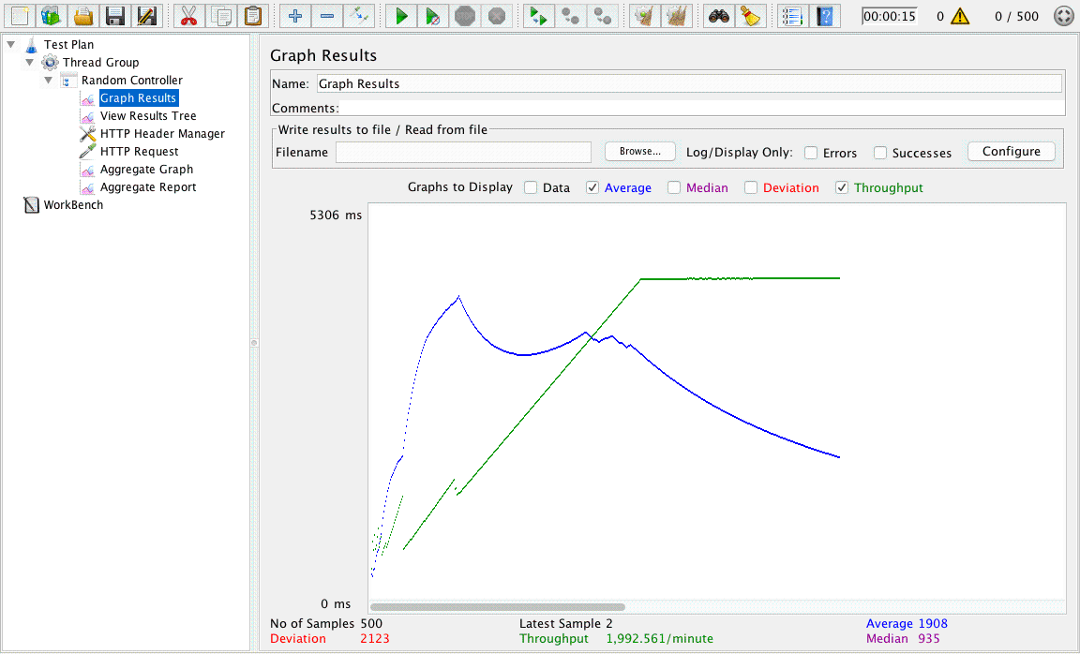



1. **DEFAULT IMPLEMENTATION**

**For 100 concurrent users with default implementation:**

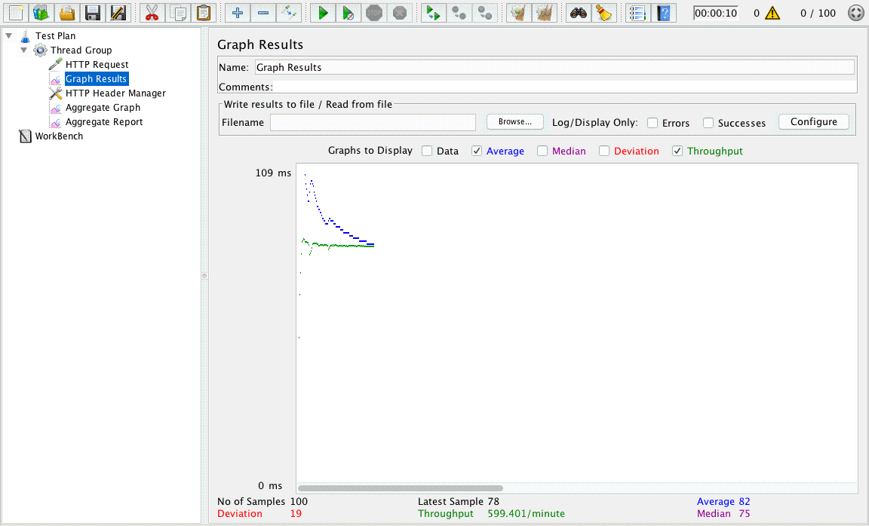



**For 200 concurrent users with default implementation:**

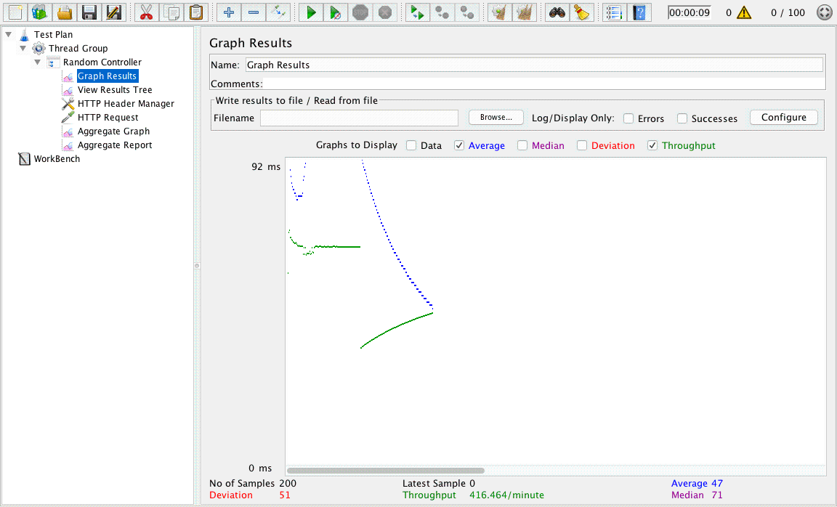



**For 300 concurrent users with default implementation:**

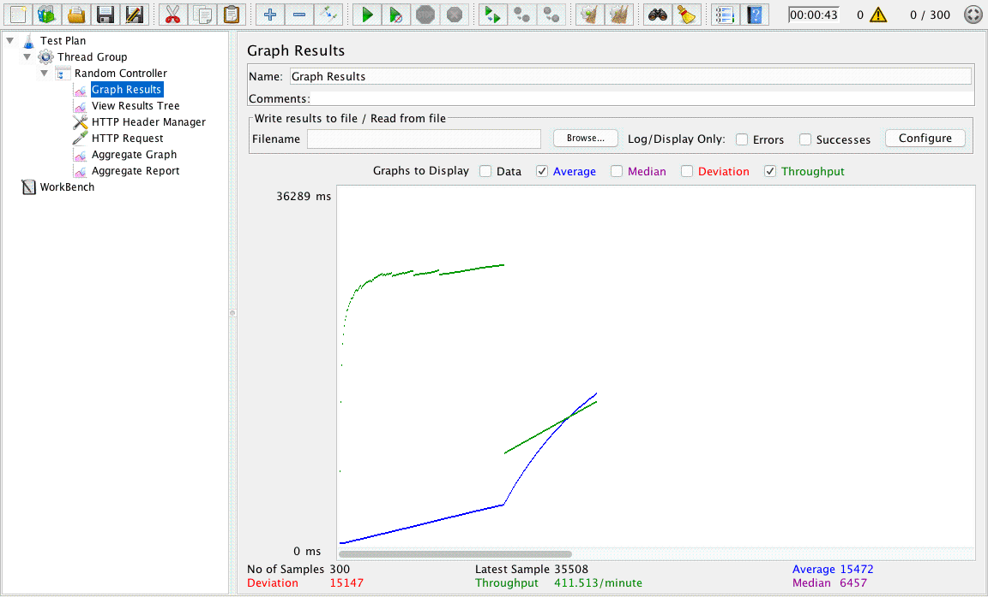



**For 400 concurrent users with default implementation:**

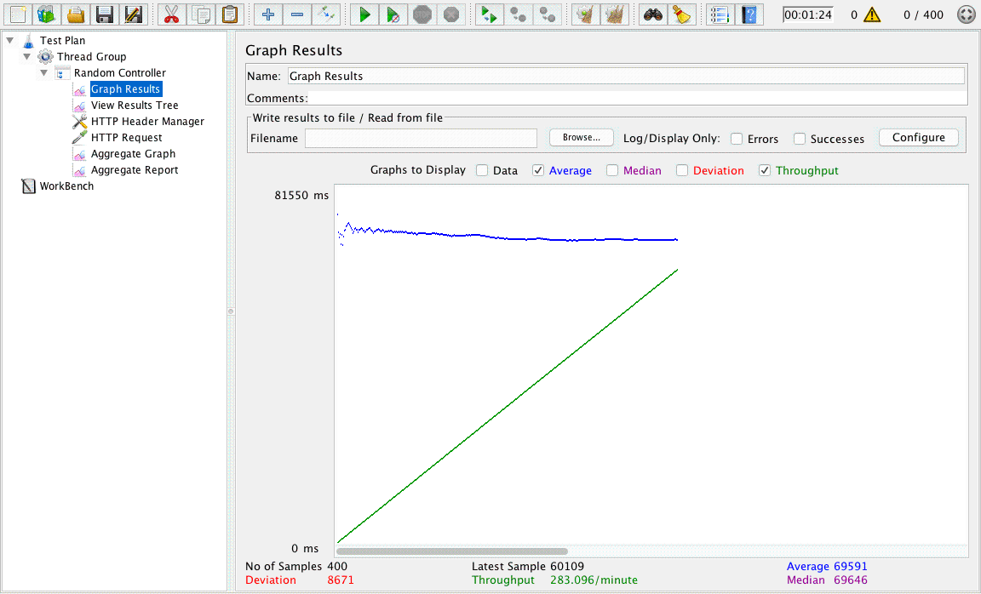



**For 500 concurrent users with default implementation:**

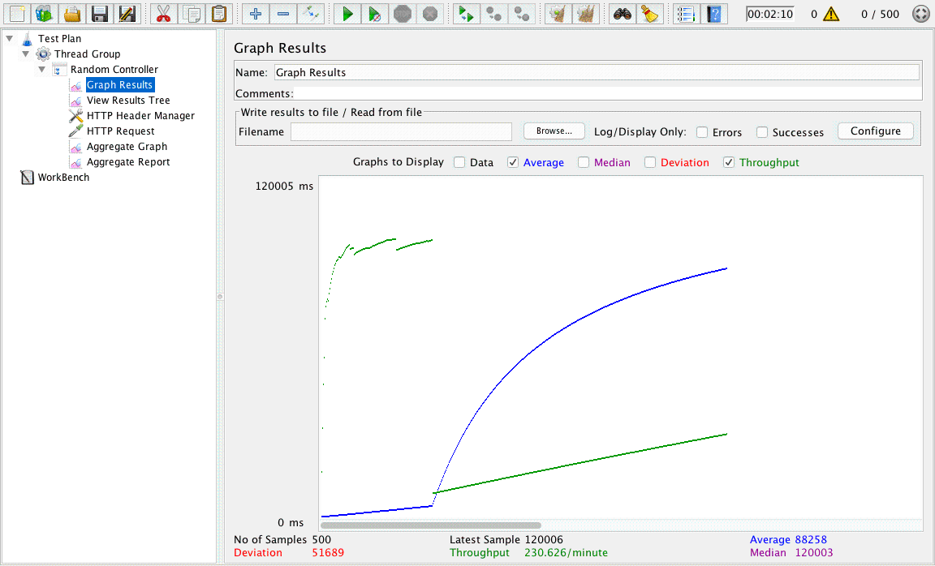



**Performance Analysis**

There are three cases for the performance analysis which have been implemented. The cases are as follows:

1. **Without connection Pooling**

In this, the performance is measured without connection pooling and the average throughput is around 500/minute for 300 concurrent users. Throughout indicates the number of transactions per second an application can handle, the amount of transactions produced over time during a test.

1. **With own implementation of Connection Pooling**

In this, pool of database connections are created and all the operations are carried out using this connection pool. Hence the throughput is higher than the one without connection pool.

On the contrary, the performance measured with this is around 1200/minute for 300 concurrent users. The performance increased to a significant value because database doesn’t have to create database connection everytime, it just assigns user the connection from existing database connection pool.

1. **DB provided Implementation of Connection Pooling**

In this, the connection pooling is the default connection pooling offered by the mongodb. It is provided by adding the pool size attribute in connect method.

The throughput measured with this is around 800/minute for 300 concurrent users. Again this is better than the one without connection pooling

**Question 1: Compare passport authentication process with the authentication process used in Lab1.**

Passport JS is used as an authentication process for Lab 2. It is an authentication middleware for Node. Its only purpose is to authenticate requests. All other functionalities are forwarded to the application by passport.

Major benefits of Passport JS are

* Centrally hosted sign-in, sign-out rather than being specific to individual site.
* Passport is based on separation of concerns which makes it easier to integrate into an application and also keeps the code clean and maintainable.
* This also makes it easy handling of success and failure.

Passport recognizes that each application has unique authentication requirements. Authentication mechanisms, known as *strategies*, are packaged as individual modules.

In previous labs, users logged in simply by providing a username and password. On the contrary with the use of Passport JS, Members do not need to retype their sign-in name and password when moving from site to site. Passport does an excellent job in providing single sign-on and at separating the other concerns of a web application from its authentication needs.

**Question 2: Compare performance with and without Kafka. Explain in detail the reason for difference in performance.**

Apache Kafka is a *high-performance open-source stream processing platform* for collecting and processing large numbers of messages in real-time.

Streaming data such as streaming data such as website click streams, events serve it downstream to stream processing applications is enabled by Kafka

Kafka is built distributed for both scalability as well as fault tolerance

Throughput measures how many events arrive within a specific amount of time. Most systems are optimized for either latency or throughput. Kafka is balanced for both. A well tuned Kafka system has just enough brokers to handle topic throughput, given the latency required to process information as it is received. Hence the performance with Kafka is better than the performance without the Kafka.

With Kafka



Without Kafka

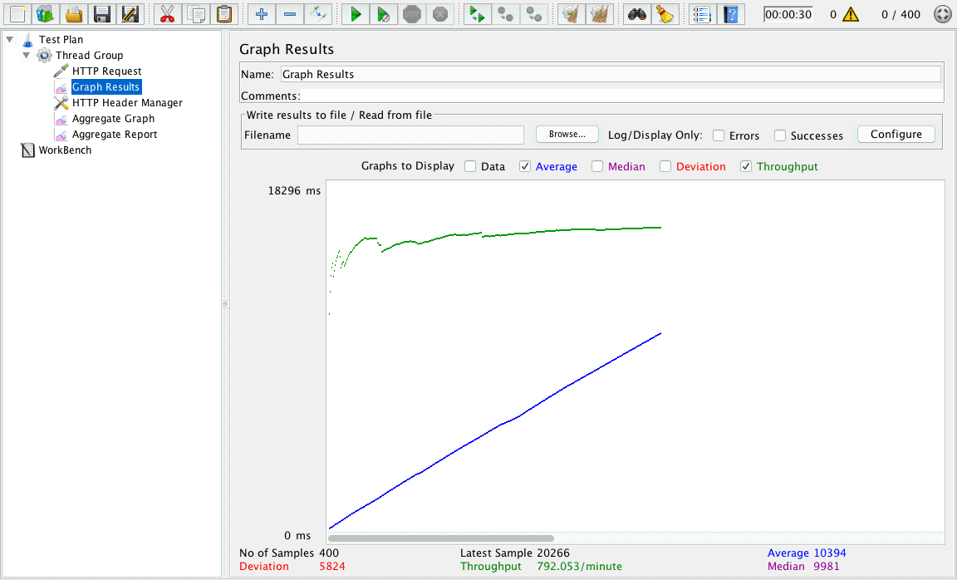

**Question 3: If given an option to implement MySQL and Mongo DB both in your application, specify which data of the applications will you store in Mongo DB and MySQL respectively**

MongoDB gives the capacity to adapt to extensive unstructured chunks of data. MongoDB helps us to meet the challenges by handling large volume of data and store it as documents. On the contrary, MySQL fails to offer speed and experience difficulties with large data volumes, so it can fit for companies having smaller databases.

As the deployments grow in terms of data volume and throughput, MongoDB scales easily with no downtime, and without changing the application. In contrast, to achieve scale with MySQL often requires significant, custom engineering work.

But there are also use cases for which database like MySQL would be a better option. Applications requiring complex, multi-row transactions would be good examples. Though we can use MySQL with MongoDB. An example could be a travel reservation system. All the complex transactions can be carried out in MySQL database i.e the core booking engine. And the other parts that involve with users like content or managing sessions could be placed in MongoDB.

There are a lot of illustrations about mixed deployments of MongoDB and MySQL. It’s just a matter of identifying the correct database for the work. For instance, a number e-commerce requisitions also use mixture of MongoDB and MySQL. The result catalog, which incorporates numerous results with diverse attributes, will be a great fit for MongoDB’s adaptable information model. On the other hand, the checkout system, which obliges complex transactions, might prone be fabricated around MySQL or in turn social innovation.